ECON 3200 R – Assignment 1  
Date: February 4, 2019  
From: Haseeb Afridi, 215-011-687  
 Veronica Shih, 214-854-970  
To: Farrokh Zandi

**Question 1**

**(A)**

|  |  |
| --- | --- |
| Supply-Side Issues   1. Power-failures at gas stations 2. Supply-chain disruptions | Demand-Side Issues   1. Change in consumer preferences; consumers demand more gasoline as they begin to hoard due to panic |

*Supply-Side*: The disaster brought upon two main difficulties for producers and retailers of gasoline products. These gas stations had to deal with power-failures due to destruction as well as disruptions in the supply chain. Originally, power-failures led the charge for gasoline shortage as many gas-stations had to temporarily shut down. This meant that other gasoline stores would be subject to a higher traffic of gasoline demand while simultaneously having to deal with the issue of dealing with supply-chain issues. Over time, as more stores began to reopen, power-failures were less of the causal factor for the shortage whereas supply-chain issues became the leading issue to handle. Where gas stations reopened and were able to supply consumers with gasoline, they had to focus on being able to supply the consumers with their demands. The gas stations had trouble finding gas to sell to consumers as they were subject to state regulations that made it difficult to source their gasoline from businesses outside of their own state. This meant that in-state supply-chain disruptions would cause a shortage of gasoline for gas stations who were hoping to fulfill demand.

*Demand-Side*: The disaster forced consumers of gasoline to become panicked. This resulted in a change in their consumption pattern for products deemed essential to live; gasoline, non-perishables, etc. These consumers determined that they would personally attempt to counteract the difficulties presented by the disaster and decided that hoarding would help minimize the problems associated. This hoarding is a temporary buff that will increase short-term demand of gasoline and other essential products.

*Summary*: The key problem is supply. Where demand issues seem to be undone with time and government intervention, supply issues tend to outlast demand issues.

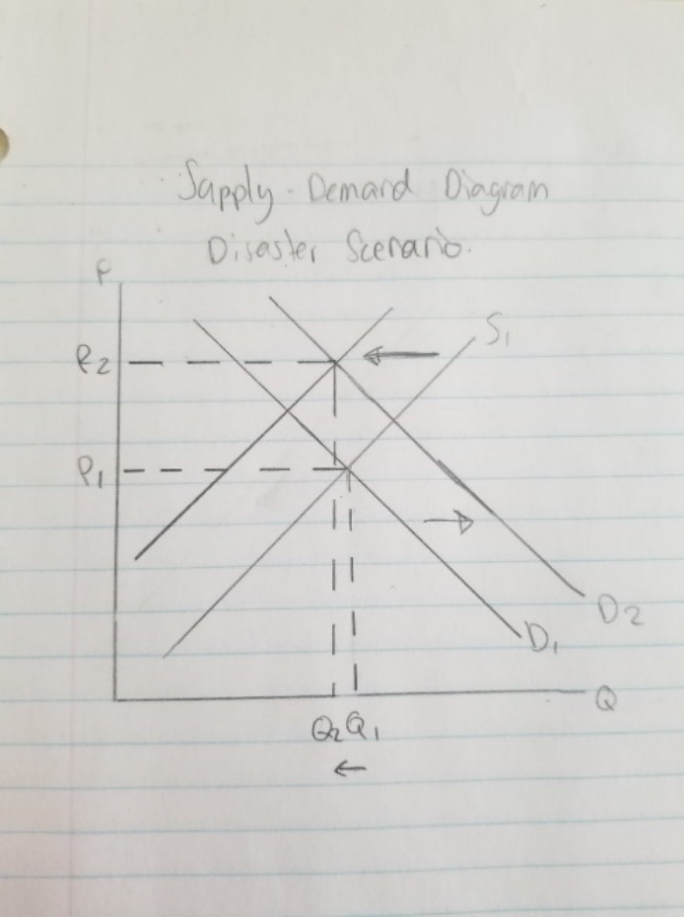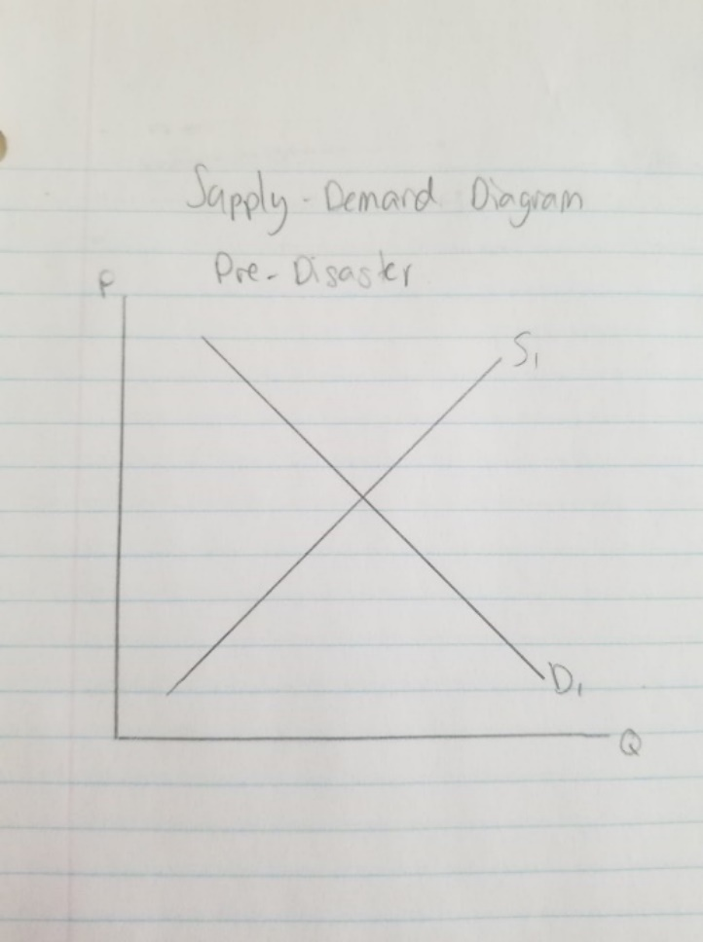

The market begins at equilibrium with normal conditions. With the introduction of the disaster, there are short-term movements in the supply and demand curves. The supply-side issues result in a shift in the supply curve to the left whereas the increase in consumer consumption behaviour results in a shift of the demand curve to the right. Because it is determined that the supply issues outweigh the demand issues, there will be a greater supply-reduction effect on quantity supplied in relation to the increase in supply associated with the increased consumer consumption behaviour. The final result will be a market where less quantity is being supplied; Q1 🡪 Q2, and more is being paid per capita of gasoline; P1 🡪 P2.

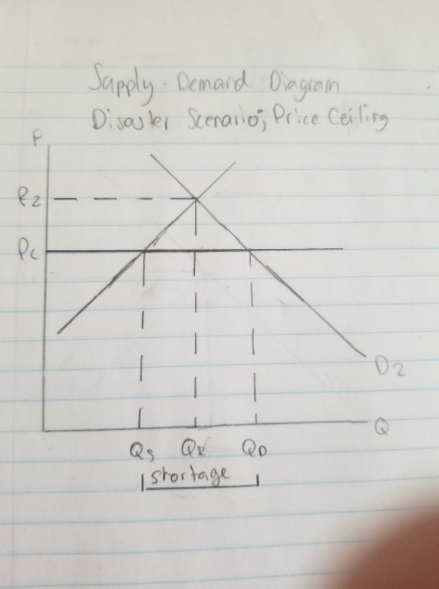With the introduction of a government-imposed price-ceiling, there will be an increased shortage in quantity supplied whereas there will be a resultant price decrease. As can be seen from P2 🡪 Pc, there is a price reduction with the mandatory government-imposed price-ceiling. However, quantity demanded increases from Q2 🡪 Qd and quantity supplied decreases from Q2 🡪 Qs, creating a shortage of gasoline denoted as the quantity between Qs 🡪 Qd. This creates a problem as producers of gasoline will be tempted to go to black markets to sell to individuals willing to pay a price higher than the price-ceiling. Government will have to step in to find a way to meet consumer demand and rationing will be used. Because gasoline is a commodity, however, there will not be a degradation effect on the quality of the good.

**(B)**

Individuals affected by this would be anyone looking to use transportation in some manner. This includes people such as:

* Workers who drive to and from work
* Individuals who rely on transportation for other means, such as education or keeping a family running
* Businesses who produce and sell goods; these individuals need a means to transport their goods and are unable to do so without gasoline
  + This may not include individuals selling services as there is a reduced dependency on gasoline

In the case of a shortage of gasoline, these individuals would have to do without gasoline or find alternative means of gasoline.

In the short term, these individuals will not be able to do much against the forces. The workers will have to stay in long lineups at limited gas stations or buy expensive gasoline from other “suppliers”, such as individuals who find arbitrage opportunities by importing gasoline from other states. Individuals such as students or parents will have to do the same as the worker or must find an alternative method of getting around, such as public transit, walking or taking a bicycle. Businesses who transport goods will charge a higher price for transporting as it has become more difficult to conduct business, resulting in higher costs for the secondary businesses selling the products, in turn resulting in price increases across the board for all imported products.

In the long term, this problem would not persist as the forces around the shortage will diminish. However, in the case that there is a long-term effect on gasoline supply, individuals affected would have to find alternative means of relying on less gasoline, such as fuel-efficient vehicles, vehicles that rely on energy apart from gasoline, such as electric vehicles, diesel-powered vehicles, etc. Businesses, however, will have to find a way to maintain operations while the problem persists. This could mean that it becomes cheaper to invest in vehicles that use less gasoline, invest in infrastructure that will allow for in-house production, or even relocation to states that do not deal with the crisis; all of which require investments in specific areas.

**(C)**

In the scenario of a shortage, there are multiple ways that the government can intervene. In the case, individuals were subject to higher prices as a result of the shortage of gasoline. Governments ruled this as “price gouging” and placed “price ceilings” on the businesses who were involved with price gouging. By fining those responsible for price gouging, the government set up a price ceiling against unfair importers which caused the shortage to be extended longer than it needed to be. The government prevented additional supplies of gasoline, making it harder for everyone to purchase gasoline. Removing the price ceiling would allow individuals who are more dependent or less price-sensitive to oil with the option of buying at a higher price without having to deal with the hassles that other individuals must face. This is ethically viable yet fails economically. The government is hoping to aid the poor and people in emergency by preventing others from “taking advantage” of their situation. If the government wanted to do so, they could have found alternative means of doing so. The government could have played around with tax laws. This includes temporarily increased taxation of states not severely affect in hopes to redistribute wealth to those who had greater needs for it.

In our opinion, the price ceiling temporarily exacerbated the situation. It reduced the overall supply of gasoline to individuals who had a necessity for it. The shortage created arbitrage opportunities for those who were able to take advantage of the situation by supplying gasoline from alternative sources. These individuals satisfied the demand of other individuals who were not against the idea of paying hefty prices for convenient gasoline.

The second policy held up well as it cut the daily demand in half. This allowed individuals to wait half the time it would have taken without the policy. However, as time progresses, individuals will accustom to the gasoline schedule. Daily gasoline demand will slowly normalize to the demand that it was prior to the natural disaster. This will be beneficial if the systems are able to recover to the amount of quantity demanded. However, if quantity supplied is unable to satisfy quantity demanded, the policy will fail in the long term.

**Question 2**

**(A)**

Enrolment ratio is the ratio of individuals enrolled in public college versus private college. As private college is relatively more expensive to public college, we can assume that the ratio will be greater than 1 as there will be more enrolments in public schooling versus private schooling. Unemployment is the independent variable whereas the enrolment ratio is the dependent ratio. What is essentially theorized in the studies of enrolment ratio vs. unemployment is that increased unemployment will result in a higher enrolment ratio; if unemployment jumps, the ratio of public school enrolment to private school enrolment will increase, suggesting that there will be a greater increase in public school enrolment relative to private school enrolment or a smaller decrease in public school enrolment relative to private school enrolment. Therefore, the variables will have the following effect on the enrolment ratio:

|  |  |  |
| --- | --- | --- |
| Variable | Effect on Enrolment Ratio | Explanation |
| Unemployment | Increase in unemployment = increase in enrolment ratio for both males and females | As the unemployment rate increases, the ratio increases as well. This means that public school enrolment increases relative to private school enrolment. This can be explained by the change in income for the population as a whole; an increase in unemployment means that the population will have less income to spend and will therefore be more inclined to spend less on education, therefore, spending less on private schools and more on public schools. This would explain the increase in the enrolment ratio increase. |
| Income | Increase in income = decrease in enrolment ratio for males, and increase in enrolment ratio for females, however, it is insignificant as the t-stat of 2.24 is greater than the required t-stat of 1.697 | As the t-stat of females is greater than the required t-stat at a significance level of 1.697, there is no correlation between the dependent variable and income for females, and therefore, we will disregard the female income independent variable. We can explain the decrease in the enrolment ratio with an increase in income by deducing that public-school education is relatively inferior to private-school education. Therefore, with an increase in income, males will be more inclined to invest in the superior good, private-school education. There will be a relative increase in private-school enrolment relative to public-school enrolment, resulting in a falling ratio. |
| Financial Aid | Increases in financial aid = decrease in the enrolment ratio for both males and females, however, both variables’ t-stats exceed the required t-stat and, therefore, they are insignificant | Since the two t-stats are exceeded, we can ignore the results of the independent variable as it is insignificant. |
| Tuition Ratio | Increase in tuition ratio = decrease in enrolment ratio for both males and females | The negative coefficient suggests that an increase in the tuition ratio will result in a decrease in the enrolment ratio. This can be explained through decreased relative price to enroll into private-school relative to public-school. The tuition ratio is the cost associated with attending public school to private school. If this ratio increases, it means that public schools will be relatively more expensive to attend than private schools, inducing a consumer consumption shift from spending more money on the relatively less expensive private school than the public school, hence the negative correlation. |
| Population | Increase in population = decrease in enrolment ratio for both males and females, however, since the t-stat for males exceeds the required 1.676, we will classify the male correlation as insignificant. | As population increases, there are more people attempting to enroll into universities, both public and private. It is fair to say that there is a greater number of individuals attempting to enroll into public schools relative to private schools as the covenants to enroll into a private school are higher and because they are more expensive. With an increase in population while holding all else constant, public schools will have difficulties providing for the increased demand for education and, will therefore, increase the enrolment requirements to maintain the number of individuals being enrolled. Private schools, however, have flexibility with finances and will be able to create spaces and resources for the additional demand and, therefore, there will be an increase in private school enrolments relative to public school enrolments, driving the ratio down. |

**(B)**  
The theorem is attempted to be applied as there is a similar good with varying quality and price points; public school, which is relatively less expensive and debated to be inferior to private schooling, the more expensive alternative. These products are subject to the relative price theorem of the third law of demand. This is captured in the regressions when referring to the tuition ratio. The regression outputs suggest that, as tuition costs for public schools increase relative to private schools, the enrolment for public schools decrease relative to enrolment for private schools. The third law of demand can be applied to this scenario; as the costs of public schooling increases relative to private schooling, individuals are more inclined to spend money on the superior good, the private schooling. This is the essence of the third law of demand; the relatively inexpensive good’s price increases more as a percentage of total price relative to the expensive good.

**(C)**

In order for the third law of demand to be supported by the regression outputs, each of the coefficients must be either positive or negative, depending on the variable:

Unemployment = ( - )  
For unemployment to satisfy the third law of demand, it must be a negative coefficient; as unemployment rises, the population has less money to spend. Because this is the case, everything will become more expensive, including private and public schooling. Private schooling will become less expensive as a percentage of total price relative to public schooling and, therefore, an increase in unemployment *should* reduce the enrolment ratio

Income, Financial Aid = ( + )  
Increased income and financial aid, assuming that financial aid can be used towards both public and private schooling, should increase the enrolment ratio. As individuals make more income or receive more financial aid, they will have more money to spend on schooling. That will make both private and public schooling cheaper by the same amount. Cost of public schooling will reduce more as a percentage of total price relative to private schooling and, therefore, the ratio *should* increase with increased income and financial aid.

Tuition Ratio = ( - )   
The tuition ratio is the cost undergone of going to public school over private school, where cost of public schooling is less than cost of private schooling. Therefore, an increase in this ratio suggests that public schooling becomes more expensive relative to private schooling. As public schooling becomes relatively more expensive, individuals *should* switch over to private schooling as it has become relatively inexpensive.

We will now see whether the regression outputs present the same finding or whether they do not support the third law of demand

ER = -0.5905 + 7.0689U + 0.1146I – 0.348F - 0.0489T – 0.0751P  
This regression output supports and rejects the expected relationship. Unemployment and Financial Aid do not support the hypothesized relationship whereas Income and the Tuition Ratio support the hypothesized relationship of schooling and the third law of demand.

ER(M) = 9.032 + 0.8753U – 0.00008I – 0.1065F – 5.4489T – 0.0029P  
This regression output mainly rejects the hypothesized relationship. Where the Tuition Ratio supports the third law of demand, the other three variables – Unemployment, Income and Financial Aid – do not support the relationship of schooling and the third law of demand.

ER(F) = -286.542 + 99.51U + 0.01515I – 4.4702F – 114.185T – 0.0636  
This regression output, much like the first output, supports and rejects the third law of demand. Where Unemployment and Financial Aid do not support the hypothesized relationship, Income and the Tuition Ratio support the hypothesized relationship of schooling and the third law of demand.

One thing to note between the regression outputs is that there lie very distinct characteristics of the outputs. It is important to note that the R^2 for ER is 49.39% whereas R^2 for ER(M) and ER(F) is 15.03% and 21.71%, respectively. These are important to keep in mind as the R^2 speaks about the correlation the raw data has with the regressed output. This means that, where the regression output for ER for the whole population explains 49.39% of the raw data, the regression outputs for both ER(M) and ER(F) explain less than 25% for both cases, suggesting that the regression output can be altered to provide a better explanation of the data. That being said, we can begin to try to explain the findings of the regression and how they support or reject the third law of demand. The third law of demand speaks to income effects and price effects. All the variables have either a price or income effect which correlates with the third law of demand.

**(D)**

Apart from the sign differences already discussed above, there are some major differences between the values of the coefficients for males and females. Where the constant is 9.032 for males, it is a whopping -286.542 for females. Where unemployment is 0.8753 for males, it is 99.510 for females. Where the tuition ratio is -5.4489 for males, it is -114.185 for females. It can be seen that the results for female enrolment ratio is heavily dependent on unemployment and the tuition ratio whereas the regression outputs for male enrolment seems to be evenly distributed amongst the variables.

**Question 3**

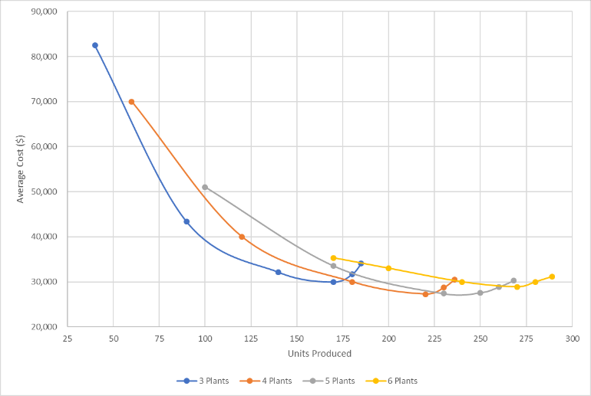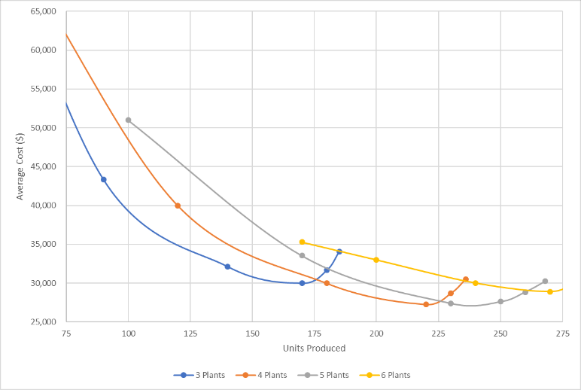**(A)**  
The above ATC curves are the same, where the one on the right is a zoomed-in version for better view.

**(B)**

As can be seen in the charts above, there exist economies and diseconomies of scale. It pays to scale up top between 4 and 5 plants as the lowest average cost is achieved producing 220 units with 4 plants at $27,273 per unit or producing 250 units with 5 plants at $27,600 per unit. There are economies of scale until these two points are achieved, after which, diseconomies of scale begin to set in.

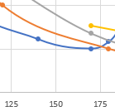**(C)**

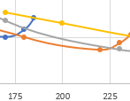i)   
in the case that the demand is 150 units, it would cost the least per unit to produce using 3 plants, as can be see with the blue line. This is because the SRAC at 3 plants lies the lowest at 150 units.

ii)   
least average cost at 200 units will be achieved by producing using 4 plants, as can be seen with the orange line. This is because the SRAC at 4 plants lies the lowest at 200 units.

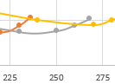iii)   
least average cost at 250 units will be best achieved by producing with 5 plants, as can be seen through the grey line. This is because the SRAC at 5 plants lies the lowest at 250 units

**(D)**

Expected Demand = (100*0.2) + (150*0.5) + (200*0.2) + (250*0.1) = 160 units

Because the expected demand is 160 units, it would be wise to invest in plants that will produce 160 units at the lowest average cost; in this case, it would be 3 plants. However, upon further examination of the distribution of demand possibilities, it can be seen that it would not be wise to stick with 3 plants as 3 plants cannot produce for 30% of the possible outputs; the option of 3 plants cannot produce more than 185 units. Therefore, it is recommended to pick the next most inexpensive option; 4 plants. Not only does this option cover the possibility of 200 units, it is only slightly more expensive than 3 plants when covering the cost of the expected demand. One can further argue to produce 5 plants in order to cover all possibilities, yet, the option of 4 plants allows for production of up to 236 units in the case that the 10% chance of 250 unit demand is met.

**Question 4**

1. **Calculate the incremental variable, or marginal, cost per chair to LP of accepting the order from Southeast.**

LP total cost includes direct labour cost, materials cost, plant overhead cost and administrative/ selling expenses. Plant overhead costs are fixed costs. We do not know whether selling and administrative cost is fixed or variable, however, will classify it as variable as selling costs are, most likely, incurred for each unit sold. Direct labour and materials cost are variable costs. Incremental or marginal cost is the addition in total variable cost that results from one unit increase of output. Hence,

MC=Direct Labor Cost + Material Costs + Selling and Administrative Costs  
MC = 2.25 + 2.30 + 0.80 = 5.35

The marginal cost to LP for taking the order from Southeast is $5.35 per chair, 15 cents less than the order price.

1. **What assumptions did you make in calculating the incremental variable cost in Question 1? What additional information would be helpful in making these calculations?**

We made the assumption that LP can produced the 30,000 chairs during the slow period using the firm’s remaining workforce and existing equipment. We also assumed that material cost will remain the same as it is during the production period. In addition, the acceptance of the offer will not lead to any additionally incurred fixed costs. Lastly, a more specific break down of the overhead cost would have been helpful in making this calculation more accurate as the order could have led to higher maintenance, heat, light, power insurance, use of selling and administration expenses, etc.

1. **Based on your answers to Questions 1 and 2, should LP accept the Southeast order?**

Economically speaking, LP should accept the offer although the per unit selling price to Southwest is less than what they originally charge to other businesses. LP’s fixed costs represent a sunk cost that must be paid regardless of whether the company accepts the offer, hence, such cost should not be considered relevant cost. The relevant cost that should be considered in the process of making the decision is the variable cost. By accepting the offer, LP will be able to produce an additional $4500 from the sale [(5.5-5.35)*30000].

1. **What additional considerations might lead LP to reject the order?**

LP might reject the order to prevent the loss of other costumers. If other warehouse stores, retail hardware’s and department stores discover that LP was selling to Southwest at a reduced price, they might require the same price or they might lose interest in working with LP. 30,000 units only stand for 6% of LP’s total production; such an order might not be worth taking the risk of ruining its relationship with other retailers.